Coffee Data Set Analysis
Introduction
The analysis is based on sales of different types of coffee items in a vending machine in Ukraine. This report consists of detailed analysis of the dataset,
that focuses on stock management using the sales and transactions of the items. In the end comes the analysis on risk management. Instead of jumping directly into conclusions, the analysis was done step by step, where each insight naturally justified the next analysis

Dataset Overview
The dataset consists of two CSV files, one for each vending machine. Each file consists of the following columns:
• date – Date of transaction (YYYY-MM-DD)
• datetime – Exact date and time of purchase
• cash_type – Payment method (cash or card)
• card – Anonymized card ID (empty values indicate cash payments)
• money – Transaction amount (Ukrainian currency)
• coffee_name – Type of beverage purchased
Item-wise purchase counts (entire dataset)
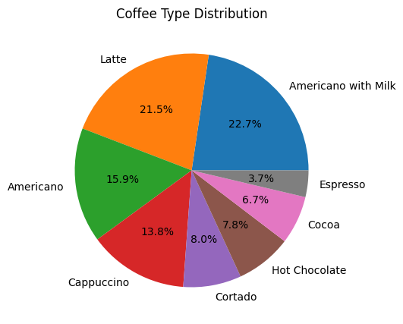
These counts already give an early signal of core vs secondary items, but deeper analysis was required before making operational decisions.
Data Cleaning
Missing values in the card column represent the usage of cash instead of card by the consumer. No significant missing values are observed. Data set has the necessary criteria to start the analysis.
Seasonal Analysis (Month Analysis)
That dataset consists of sales data of a year that starts from March 2024 to March 2025.
New column month has been added for the analysis from the date column.
This gives us the opportunity to use the months to find their respective number starting January being 1 to December being 12. These numbers are used to split the months into respective seasons, Autumn, Spring, Summer and Winter.
Using Line Graph shows that moderate seasonal variation is observed, demand spikes appear more strongly in transitional or routine-reestablishment periods such as October and February, rather than consistently across entire seasons.
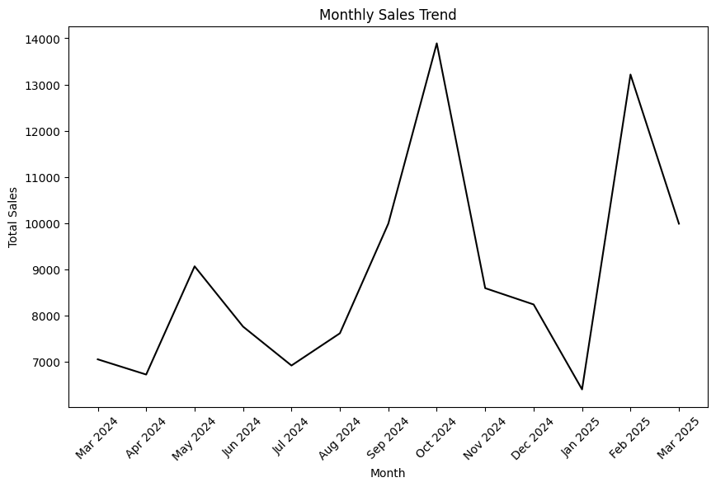

This graph gives the Item distribution by Season.
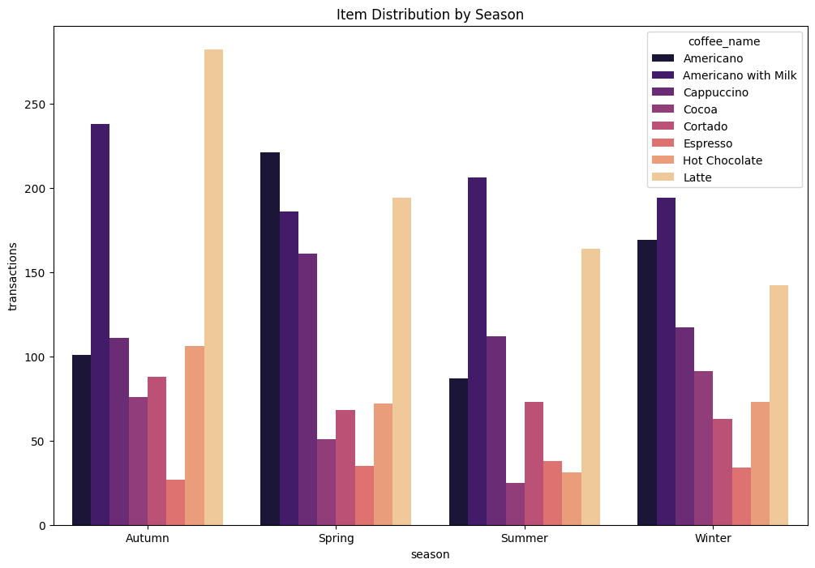
Latte and Americano with Milk excels in making sales and transactions, followed by Americano and Cappuccino.

Customer Segmentation (Based on Repeat Purchases)
Customers were grouped based on how many times they appeared in the dataset using the same card ID. These bins represent repeat purchase behaviour, not demographics.
One-time purchase (0–1 transactions), Occasional (2–5 transactions), Regular (6–20 transactions), Heavy (20+ transactions).
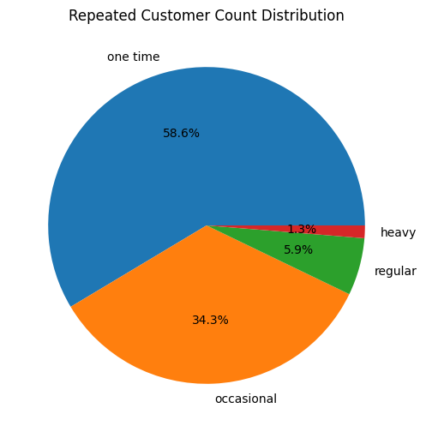
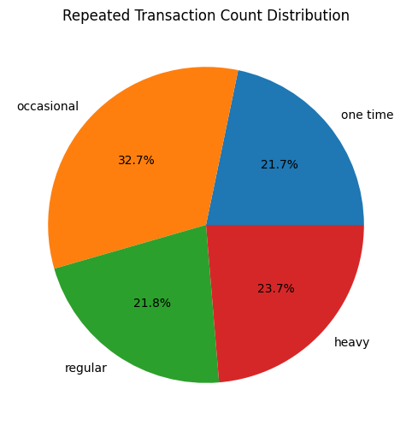
This gives us that Customer distribution does not depend on the sales generated. We can see that less heavy users does produce almost same revenue as same as one-time users.
Key takeaway from this is, a very small group of heavy users contributes disproportionately to revenue. Losing them would be far more costly than losing one-time users.
Item Preference by Customer Category
Across all customer categories, the same drinks repeatedly appear at the top:
• Latte
• Americano with Milk
• Americano
• Cappuccino
These are core SKUs (Stock Keeping Units) that are low-risk, high-demand, and universally preferred.

Behavioural Pattern of Customers
• One-time users show slight experimentation and testing that includes items Cocoa and Hot Chocolate.
• Occasional users start concentrating on Latte and Americano with Milk.
• Regular users show strong habitual preference
• Heavy users are highly routine-driven, especially toward Latte
This confirms that replenishment decisions must prioritize core items first.
The next is the graph of top coffee revenue by each customer category.
As always Latte and Americano with milk excels in sales by each customer category. This also proves that these are the core SKUs and must be always replenished and keep the stock of them alive.
The Difference between each Category here are more attention towards Latte and Americano with Milk. Some towards Hot chocolate and Cocoa too so not a big insight. These users are at exploring and experimenting the stock in this new vending machine.
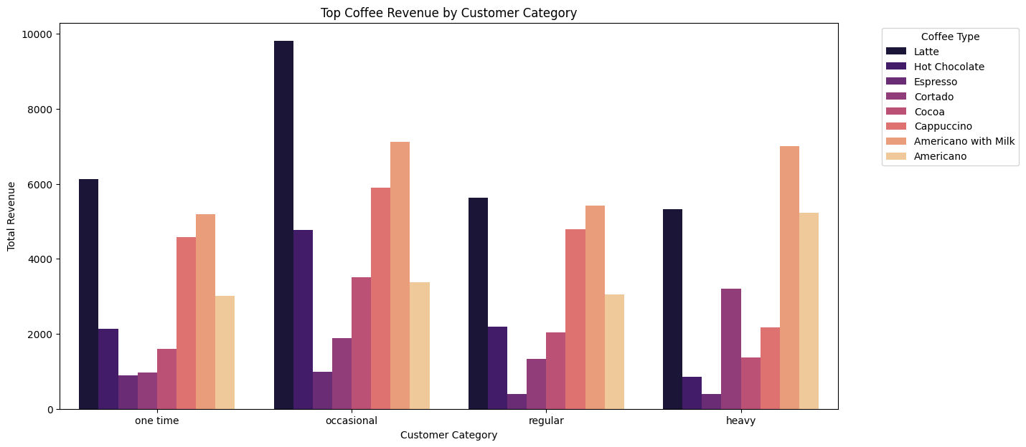

Now about Occasional users Clear Concentration is on Latte, Americano with Milk and Cappuccino and less randomness since they are occasional users. This is the conversion stage.
About Regular customers Latte, Americano with Milk and Cappuccino and the concentration of the sales is also more. This says that people are buying the drinks regularly basically forming habits.
Now about Heavy Users Latte is the one that excels in sales later with Americano with Milk and these people are buying the drinks in their routine.

Week Analysis
By using inbuilt functions in python each transaction is being assigned with their respective week number starting from first week of March 2024 as 1 to last week of March 2025 as 52.
The below is the graph of distribution of sales/transactions with respective to week.
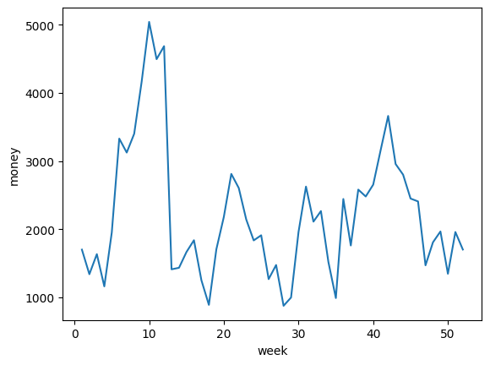

From the above distribution Weeks 10,12,11,42,8,6,41,7,43,21,9 are the top 10 sales generating weeks.
Day Analysis
Each observation has been assigned a new attribute called day taken from the date column. This attribute helps in finding trends in a week, finding usage patterns of the vending machine across a week.
From finding the overall total sales among each day in a week, Tuesday comes first followed by Monday, Wednesday, Thursday and Fridays with slight difference in their total sales. Least total sales was observed on Sunday.
Following is the plot of the composition of average sales on each day.
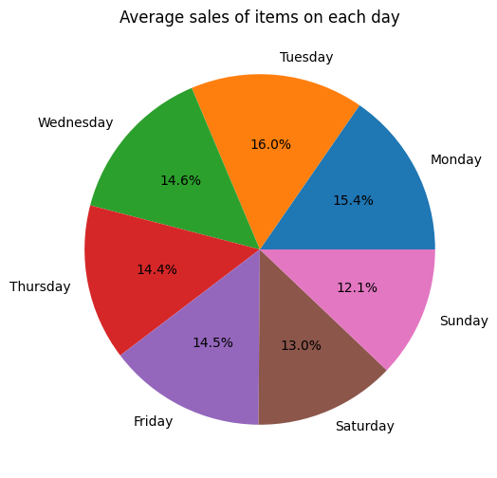

This pattern suggests routine-driven weekday demand, not weekend-driven leisure demand.
Operational implication: Sunday is the safest day for refilling or maintenance.

Time of Day Analysis
Using the datetime column to find the exact time of purchase. This helps in making a new attribute called time_of_day.
Time of day consists of
• Morning (06:00–10:59)
• Afternoon (11:00–14:59)
• Evening (15:00–18:59)
• Night (19:00–05:59)
Below is the graph of Distribution of transactions count by time of day and customer category.
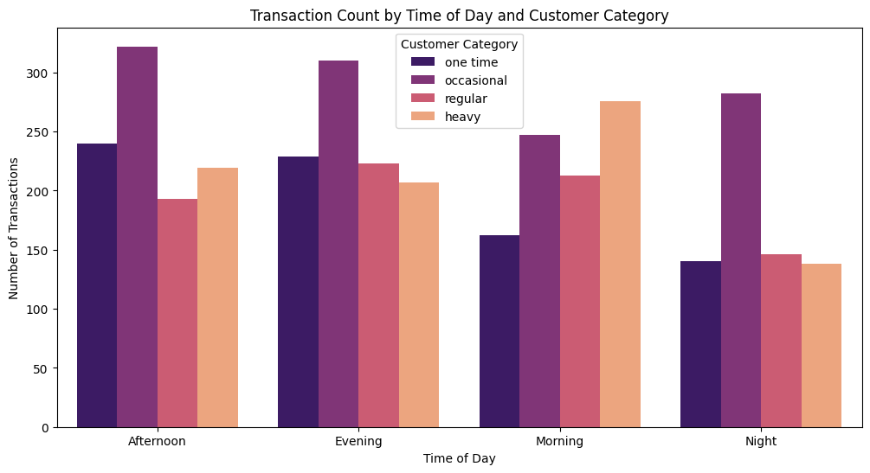

We can observe that occasional users generally excel in making transactions during almost at every time of day(here Morning, Afternoon, Evening, Night).

Next Plot gives us the information on the distribution of transactions with respective to time of day and the Coffee type.
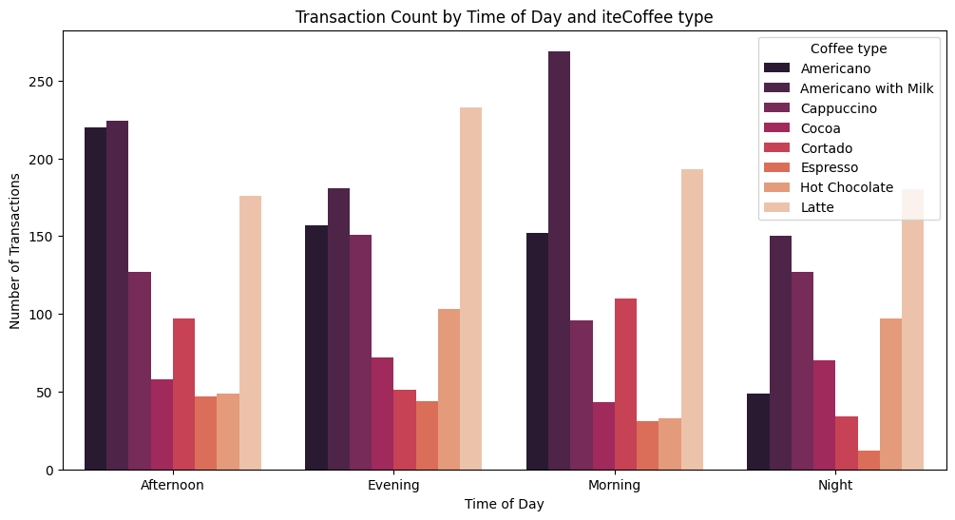
From the above plot we can conclude that item-level demand varies significantly by time of day.
Core beverages such as Latte and Americano with Milk and Americano dominate across all periods, while secondary items exhibit time-specific importance. This segmentation enables prioritization of stock levels during replenishment without disrupting peak customer interactions.
Refill Frequency (Week-of-Month Analysis)
By using the date column, we make a new column named week_of_month that denotes the specific week of that specific month. That is 1 denotes the first week of that specific month. Similarly,1 → days 1–7
2 → days 8–14
3 → days 15–21
4 → days 22–28
5 → remaining days (if any)
This helps in finding the best week for stock replenishment in the vending machine.
The following graph shows the distribution of refill frequency. These percentages are taken from the relation between week of month and percentage of transactions they make in total.
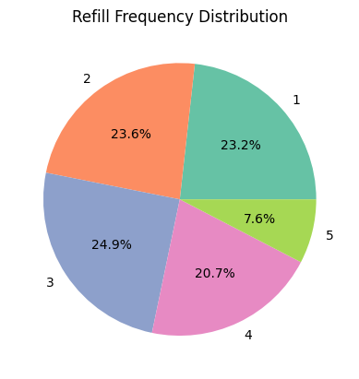
From the distribution we can conclude the transactions are almost equally distributed.
This concludes that refill frequency must be done every week rather than once every month, twice or thrice.
Final Recommendations
• Replenishment frequency: Weekly
• Best day: Sunday
• Best time: Night
• Stock priority:
1. Latte
2. Americano with Milk
3. Americano
4. Time-dependent secondary items
A one-day outage can be costly and should be fixed the same day, preferably at night. Redirecting customers to a nearby machine can mitigate losses only if the alternative is very close.
Note on Price Variations
Minor price differences were observed (e.g., Latte prices varying slightly by time). Given the small dataset (~3900 observations), narrow price range, and routine-driven behaviour, these variations are not meaningful drivers of demand.
This anomaly was acknowledged but intentionally not modelled. In real-world settings with larger datasets or controlled pricing changes, such variations may warrant deeper analysis.
Final Thoughts
This project demonstrates how simple, well-structured analysis can lead to practical operational decisions without forcing machine learning where it doesn’t belong. The focus was on availability, timing, customer behaviour, and risk—the real levers of a vending machine business.

